**WEEK 1 : Design patterns and principles**

**Exercise 1: Implement Singleton Pattern**

**Code:**

**package week_1.Design_Patterns_Principles;**

**class Logger {**

**private static Logger *instance*;**

**private Logger() {**

**System.*out*.println("Logger instance created.");**

**}**

**public static Logger getInstance() {**

**if (*instance* == null) {**

***instance* = new Logger();**

**}**

**return *instance*;**

**}**

**public void log(String message) {**

**System.*out*.println("Log: " + message);**

**}**

**}**

**class SingletonPatternExample {**

**public static void main(String[] args) {**

**Logger logger1 = Logger.*getInstance*();**

**logger1.log("First message");**

**Logger logger2 = Logger.*getInstance*();**

**logger2.log("Second message");**

**System.*out*.println(logger1 == logger2);**

**}**

**}**

**Output:**

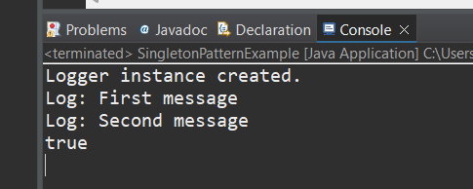

**Exercise 2: Implementing the Factory Method Pattern**

**Code:**

**package week_1.Design_Patterns_Principles;**

**interface Document {**

**void open();**

**}**

**class WordDocument implements Document {**

**public void open() {**

**System.*out*.println("Opening Word Document...");**

**}**

**}**

**class PdfDocument implements Document {**

**public void open() {**

**System.*out*.println("Opening PDF Document...");**

**}**

**}**

**class ExcelDocument implements Document {**

**public void open() {**

**System.*out*.println("Opening Excel Document...");**

**}**

**}**

**abstract class DocumentFactory {**

**public abstract Document createDocument();**

**}**

**class WordDocumentFactory extends DocumentFactory {**

**public Document createDocument() {**

**return new WordDocument();**

**}**

**}**

**class PdfDocumentFactory extends DocumentFactory {**

**public Document createDocument() {**

**return new PdfDocument();**

**}**

**}**

**class ExcelDocumentFactory extends DocumentFactory {**

**public Document createDocument() {**

**return new ExcelDocument();**

**}**

**}**

**public class FactoryMethodPatternExample {**

**public static void main(String[] args) {**

**DocumentFactory factory = new WordDocumentFactory();**

**Document doc = factory.createDocument();**

**doc.open();**

**factory = new PdfDocumentFactory();**

**doc = factory.createDocument();**

**doc.open();**

**factory = new ExcelDocumentFactory();**

**doc = factory.createDocument();**

**doc.open();**

**} }**

**Output:**

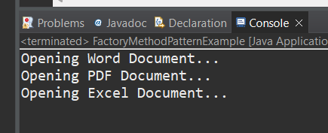

⇒ Additional Important hands-on

**Exercise 3: Implementing Builder Pattern**

**Code:**

**package week_1.Design_Patterns_Principles;**

**public class Computer {**

**private String CPU;**

**private String RAM;**

**private String storage;**

**private Computer(Builder builder) {**

**this.CPU = builder.CPU;**

**this.RAM = builder.RAM;**

**this.storage = builder.storage;**

**}**

**public static class Builder {**

**private String CPU;**

**private String RAM;**

**private String storage;**

**public Builder setCPU(String cpu) {**

**this.CPU = cpu;**

**return this;**

**}**

**public Builder setRAM(String ram) {**

**this.RAM = ram;**

**return this;**

**}**

**public Builder setStorage(String storage) {**

**this.storage = storage;**

**return this;**

**}**

**public Computer build() {**

**return new Computer(this);**

**}**

**}**

**public String toString() {**

**return "Computer [CPU=" + CPU + ", RAM=" + RAM + ", Storage=" + storage + "]";**

**}**

**public static void main(String[] args) {**

**Computer comp1 = new Computer.Builder()**

**.setCPU("Intel i5")**

**.setRAM("16GB")**

**.setStorage("512GB SSD")**

**.build();**

**Computer comp2 = new Computer.Builder()**

**.setCPU("AMD Ryzen 7")**

**.setRAM("32GB")**

**.setStorage("1TB SSD")**

**.build();**

**System.*out*.println(comp1);**

**System.*out*.println(comp2);**

**}**

**}**

**Output:**

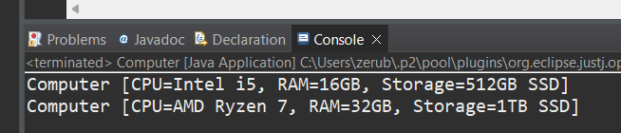

**Exercise 4: Implementing the Adapter Pattern**

**Code:**

**package week_1.Design_Patterns_Principles;**

**interface PaymentProcessor {**

**void processPayment(double amount);**

**}**

**class PayPalGateway {**

**public void sendPayment(double amount) {**

**System.*out*.println("Paid " + amount + " using PayPal.");**

**}**

**}**

**class StripeGateway {**

**public void makePayment(double amount) {**

**System.*out*.println("Paid " + amount + " using Stripe.");**

**}**

**}**

**class PayPalAdapter implements PaymentProcessor {**

**private PayPalGateway paypal;**

**public PayPalAdapter(PayPalGateway paypal) {**

**this.paypal = paypal;**

**}**

**public void processPayment(double amount) {**

**paypal.sendPayment(amount);**

**}**

**}**

**class StripeAdapter implements PaymentProcessor {**

**private StripeGateway stripe;**

**public StripeAdapter(StripeGateway stripe) {**

**this.stripe = stripe;**

**}**

**public void processPayment(double amount) {**

**stripe.makePayment(amount);**

**}**

**}**

**public class AdapterPatternExample {**

**public static void main(String[] args) {**

**PaymentProcessor paypalProcessor = new PayPalAdapter(new PayPalGateway());**

**paypalProcessor.processPayment(100.0);**

**PaymentProcessor stripeProcessor = new StripeAdapter(new StripeGateway());**

**stripeProcessor.processPayment(200.0);**

**}**

**}**

**Output:**

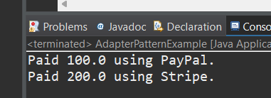

**Exercise 5: Implementing the Decorator Pattern**

**Code**:

**package week_1.Design_Patterns_Principles;**

**interface Notifier {**

**void send(String message);**

**}**

**class EmailNotifier implements Notifier {**

**public void send(String message) {**

**System.*out*.println("Email sent: " + message);**

**}**

**}**

**abstract class NotifierDecorator implements Notifier {**

**protected Notifier notifier;**

**public NotifierDecorator(Notifier notifier) {**

**this.notifier = notifier;**

**}**

**public void send(String message) {**

**notifier.send(message);**

**}**

**}**

**class SMSNotifierDecorator extends NotifierDecorator {**

**public SMSNotifierDecorator(Notifier notifier) {**

**super(notifier);**

**}**

**public void send(String message) {**

**super.send(message);**

**System.*out*.println("SMS sent: " + message);**

**}**

**}**

**class SlackNotifierDecorator extends NotifierDecorator {**

**public SlackNotifierDecorator(Notifier notifier) {**

**super(notifier);**

**}**

**public void send(String message) {**

**super.send(message);**

**System.*out*.println("Slack message sent: " + message);**

**}**

**}**

**public class DecoratorPatternExample {**

**public static void main(String[] args) {**

**Notifier notifier = new EmailNotifier();**

**Notifier smsNotifier = new SMSNotifierDecorator(notifier);**

**Notifier slackNotifier = new SlackNotifierDecorator(smsNotifier);**

**slackNotifier.send("System update completed.");**

**}**

**}**

**Output:**

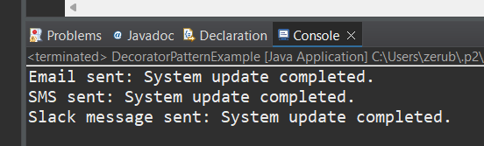

**Exercise 6: Implementing Proxy Pattern**

**Code:**

**package week_1.Design_Patterns_Principles;**

**interface Image {**

**void display();**

**}**

**class RealImage implements Image {**

**private String filename;**

**public RealImage(String filename) {**

**this.filename = filename;**

**loadImageFromDisk();**

**}**

**private void loadImageFromDisk() {**

**System.*out*.println("Loading " + filename);**

**}**

**public void display() {**

**System.*out*.println("Displaying " + filename);**

**}**

**}**

**class ProxyImage implements Image {**

**private RealImage realImage;**

**private String filename;**

**public ProxyImage(String filename) {**

**this.filename = filename;**

**}**

**public void display() {**

**if (realImage == null) {**

**realImage = new RealImage(filename);**

**}**

**realImage.display();**

**}**

**}**

**public class ProxyPatternExample {**

**public static void main(String[] args) {**

**Image img1 = new ProxyImage("photo1.jpg");**

**Image img2 = new ProxyImage("photo2.jpg");**

**img1.display();**

**img1.display();**

**img2.display();**

**} }**

**Output:**

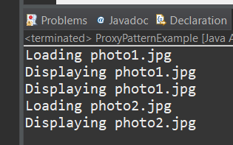

**Exercise 7: Implementing the Observer Pattern**

**Code:**

**package week_1.Design_Patterns_Principles;**

**import java.util.ArrayList;**

**import java.util.List;**

**interface Observer {**

**void update(float price);**

**}**

**interface Stock {**

**void register(Observer o);**

**void deregister(Observer o);**

**void notifyObservers();**

**}**

**class StockMarket implements Stock {**

**private List<Observer> observers = new ArrayList<>();**

**private float stockPrice;**

**public void setStockPrice(float price) {**

**this.stockPrice = price;**

**notifyObservers();**

**}**

**public void register(Observer o) {**

**observers.add(o);**

**}**

**public void deregister(Observer o) {**

**observers.remove(o);**

**}**

**public void notifyObservers() {**

**for (Observer o : observers) {**

**o.update(stockPrice);**

**}**

**}**

**}**

**class MobileApp implements Observer {**

**public void update(float price) {**

**System.*out*.println("MobileApp - Stock price updated: " + price);**

**} }**

**class WebApp implements Observer {**

**public void update(float price) {**

**System.*out*.println("WebApp - Stock price updated: " + price);**

**} }**

**public class ObserverPatternExample {**

**public static void main(String[] args) {**

**StockMarket stockMarket = new StockMarket();**

**Observer mobileApp = new MobileApp();**

**Observer webApp = new WebApp();**

**stockMarket.register(mobileApp);**

**stockMarket.register(webApp);**

**stockMarket.setStockPrice(100.5f);**

**stockMarket.setStockPrice(102.75f);**

**} }**

**Output:**

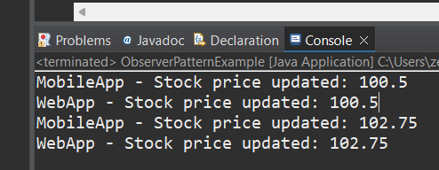

**Exercise 8: Implementing the Strategy Pattern**

**Code:**

**package week_1.Design_Patterns_Principles;**

**interface PaymentStrategy {**

**void pay(double amount);**

**}**

**class CreditCardPayment implements PaymentStrategy {**

**public void pay(double amount) {**

**System.*out*.println("Paid " + amount + " using Credit Card.");**

**}**

**}**

**class PayPalPayment implements PaymentStrategy {**

**public void pay(double amount) {**

**System.*out*.println("Paid " + amount + " using PayPal.");**

**} }**

**class PaymentContext {**

**private PaymentStrategy strategy;**

**public void setPaymentStrategy(PaymentStrategy strategy) {**

**this.strategy = strategy;**

**}**

**public void payAmount(double amount) {**

**strategy.pay(amount);**

**} }**

**public class StrategyPatternExample {**

**public static void main(String[] args) {**

**PaymentContext context = new PaymentContext();**

**context.setPaymentStrategy(new CreditCardPayment());**

**context.payAmount(250.0);**

**context.setPaymentStrategy(new PayPalPayment());**

**context.payAmount(500.0);**

**} }**

**Output:**

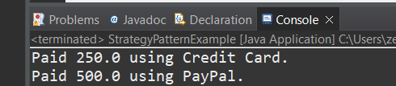

**Example 9: Implementing the Command Pattern**

**Code:**

**package week_1.Design_Patterns_Principles;**

**interface Command {**

**void execute();**

**}class Light {**

**public void turnOn() {**

**System.*out*.println("Light is ON.");**

**}**

**public void turnOff() {**

**System.*out*.println("Light is OFF.");**

**} }**

**class LightOnCommand implements Command {**

**private Light light;**

**public LightOnCommand(Light light) {**

**this.light = light;**

**}**

**public void execute() {**

**light.turnOn();**

**} }**

**class LightOffCommand implements Command {**

**private Light light;**

**public LightOffCommand(Light light) {**

**this.light = light;**

**}**

**public void execute() {**

**light.turnOff();**

**} }**

**class RemoteControl {**

**private Command command;**

**public void setCommand(Command command) {**

**this.command = command;**

**}**

**public void pressButton() {**

**command.execute();**

**} }**

**public class CommandPatternExample {**

**public static void main(String[] args) {**

**Light light = new Light();**

**Command onCommand = new LightOnCommand(light);**

**Command offCommand = new LightOffCommand(light);**

**RemoteControl remote = new RemoteControl();**

**remote.setCommand(onCommand);**

**remote.pressButton();**

**remote.setCommand(offCommand);**

**remote.pressButton();**

**} }**

**Output:**

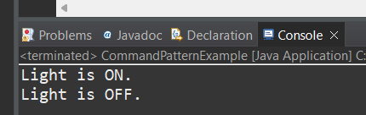

**Exercise 10: Implementing the MVC pattern**

**Code:**

**class Student {**

**private String name;**

**private String id;**

**private String grade;**

**public Student(String name, String id, String grade) {**

**this.name = name;**

**this.id = id;**

**this.grade = grade;**

**}**

**public String getName() { return name; }**

**public String getId() { return id; }**

**public String getGrade() { return grade; }**

**public void setName(String name) { this.name = name; }**

**public void setGrade(String grade) { this.grade = grade; }**

**}**

**class StudentView {**

**public void displayStudentDetails(Student student) {**

**System.*out*.println("Student: ");**

**System.*out*.println("Name: " + student.getName());**

**System.*out*.println("ID: " + student.getId());**

**System.*out*.println("Grade: " + student.getGrade());**

**} }**

**class StudentController {**

**private Student model;**

**private StudentView view;**

**public StudentController(Student model, StudentView view) {**

**this.model = model;**

**this.view = view;**

**}**

**public void setStudentName(String name) {**

**model.setName(name);**

**}**

**public void setStudentGrade(String grade) {**

**model.setGrade(grade);**

**}**

**public void updateView() {**

**view.displayStudentDetails(model);**

**} }**

**public class MVCPatternExample {**

**public static void main(String[] args) {**

**Student model = new Student("Varsha", "226", "A");**

**StudentView view = new StudentView();**

**StudentController controller = new StudentController(model, view);**

**controller.updateView();**

**controller.setStudentName("Varsha R");**

**controller.setStudentGrade("B+");**

**controller.updateView();**

**} }**

**Output:**

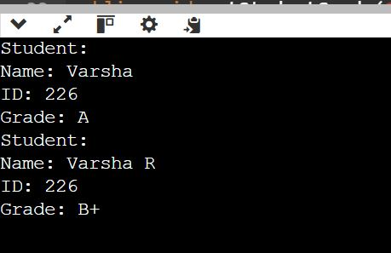

**Exercise 11: Implementing Dependency Injection**

**Code:**

**package week_1.Design_Patterns_Principles;**

**class Customer {**

**private int id;**

**private String name;**

**private String email;**

**public Customer(int id, String name, String email) {**

**this.id = id;**

**this.name = name;**

**this.email = email;**

**}**

**public int getId() { return id; }**

**public String getName() { return name; }**

**public String getEmail() { return email; }**

**}**

**interface CustomerRepository {**

**Customer findCustomerById(int id);**

**}**

**class CustomerRepositoryImpl implements CustomerRepository {**

**public Customer findCustomerById(int id) {**

**if (id == 101) {**

**return new Customer(101, "Varsha", "varsha123@gmail.com");**

**} else if (id == 102) {**

**return new Customer(102, "Ravi", "ravi123@gmail.com");**

**} else {**

**return null;**

**}**

**}**

**}**

**class CustomerService {**

**private CustomerRepository repository;**

**public CustomerService(CustomerRepository repository) {**

**this.repository = repository;**

**}**

**public void getCustomerDetails(int id) {**

**Customer customer = repository.findCustomerById(id);**

**if (customer != null) {**

**System.*out*.println("Customer ID: " + customer.getId());**

**System.*out*.println("Customer Name: " + customer.getName());**

**System.*out*.println("Customer Email: " + customer.getEmail());**

**} else {**

**System.*out*.println("Customer not found with ID: " + id);**

**}**

**}**

**}**

**public class DependencyInjectionExample {**

**public static void main(String[] args) {**

**CustomerRepository repository = new CustomerRepositoryImpl();**

**CustomerService service = new CustomerService(repository);**

**service.getCustomerDetails(101);**

**System.*out*.println();**

**service.getCustomerDetails(102);**

**System.*out*.println();**

**service.getCustomerDetails(999);**

**}**

**}**

**Output:**

